Welcome to House 6B!

General Classroom Policy
Mrs. Beggs
beggsa@foxborough.k12.ma.us
(508) 543-1610 ext. 54138
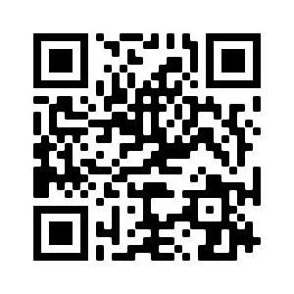
https://sites.google.com/site/campellone138/home
Miss McGinnis
mcginnise@foxborough.k12.ma.us
(508) 543-1610 ext. 54136
https://msmcginnisahern6.weebly.com/

Homework: Homework includes reading and written assignments, as well as studying for tests. In addition to nightly homework and studying, there will also be long-term projects that students will be expected to work on throughout the year. All homework assignments will be posted on our websites.
Late Work: Students are expected to complete all assignments for the day they are due. Late work will be accepted for partial credit at the discretion of the teacher.
Absences: It is the student’s responsibility to ask the teacher for the work that they missed when he/she is absent. All work must be completed within one week of the absence and any missing assignments will result in zero. If a child is away for a vacation, makeup work will be provided upon his/her return.
PowerSchool: Please use PowerSchool to monitor student progress. Grades are updated on a regular basis and PowerSchool should be checked weekly so that both students and parents are up to date on the student’s progress. If there are any questions regarding missing assignments, the student should speak with the teacher.
After School: Miss McGinnis will be available after school on Mondays and Mrs. Beggs will be after school on Tuesdays. Students who are planning to take the late bus must sign up on the Ahern’s website 24 hours in advance. After school dates are subject to change. Please check our websites for updates.
Expectations for Students:
- Follow all classroom and school rules, as detailed in the Ahern Handbook.
- Respect your teacher, self, classmates, and school property.
- Be prepared for class and keep materials organized in your folders.
- Put your best effort into completing all assignments and homework for when they are due.
Grade 6 Topics of Study

Mathematics
Throughout the course of the year in math, we will be learning about the following topics: ratios and percents; operations with whole numbers, fractions and decimals; integers and the coordinate plane; expressions, equations, functions, and inequalities; area, surface area, and volume; and statistics. We will differentiate learning through the use of a workshop model. There will be weekly homework assignments that are due on Fridays.

Science
In sixth grade, students will perform inquiry labs and complete learning activities in the areas of earth, life, and physical science. There are curricular resources available for students on the StemScopes website. The link is on my teacher website.

English Language Arts
This year all 6th grade students will read the novels Refugee by Alan Gratz and A Long Walk to Water by Linda Sue Park. Students will engage in book clubs, write reading responses, and produce book projects. They will also be responsible for completing narrative, argument, and informational writing assignments.

Social Studies
This year’s sixth grade social studies curriculum will be a blend of world geography and ancient civilizations. We will be using various sources, including an online textbook which students can access through their McGraw Hill ConnectEd login. Students should expect some projects over the course of the year.

